

**Inversiones Natasha Real Estate**

**http://inversionesnatasha.com/**

**logo1.png**

**Search Engine Optimization**

**The Background**

Inversiones Natasha (**Spanish language website**) serves as a premier destination for real estate deals in Panama. Being a recognized pioneer in the industry of real estate, the company develops and promotes residential, commercial and industrial properties. Founded by entrepreneurs Lic Ivan Carlucci Sucre and Natasha Sucre Benjamin in the year 1991, the company helps clients to make smart decisions when buying, selling and renting properties in Panama. The company also offers brokerage services to sell and lease property in an accessible range in Panama City.

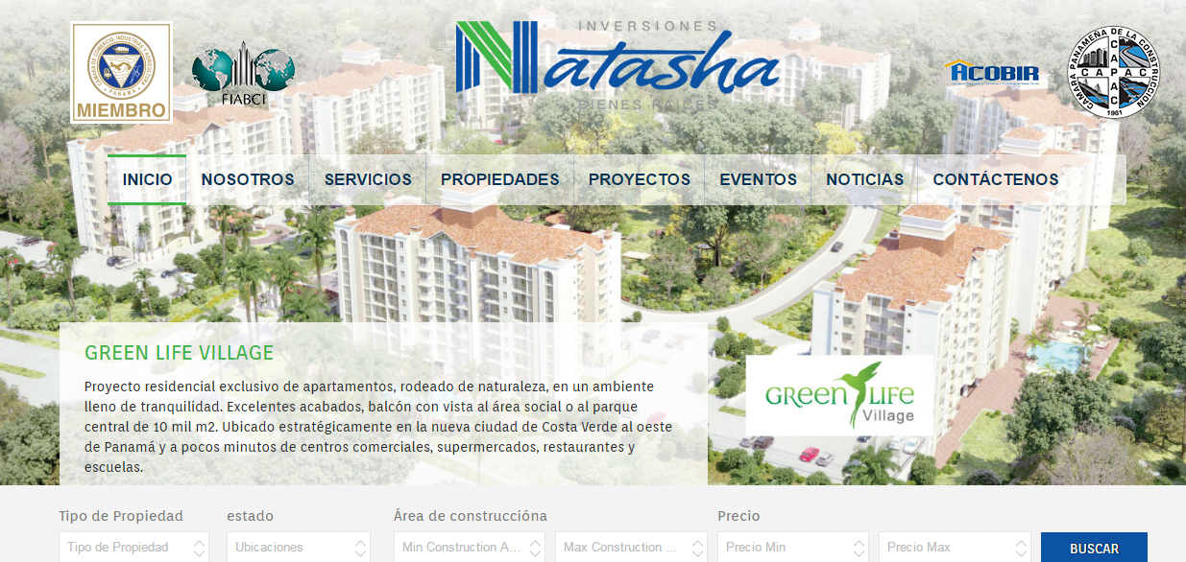

**The Challenge:**

**Creating a Powerful Digital Presence & Striving for Brand Recognition**

The keywords were not even in top 100 of the search results, for the entire targeted keyword phrases. Needless to say, the owners of Inversiones Natasha were doubtful about good ranking in Google. Their aim was to rank high in Google and their ultimate goal was to defeat their competitors and achieve top ranking. In addition, the lack of a focused keyword strategy prevented search engine spiders to crawl for the content, which have been fixed on priority.

We started the project work with a complete Market Analysis, and researching on effective search engine optimization (SEO) methodologies. The search engine ranking of targeted keywords were pretty low. On checking the website performance based on traffic, ranking, and conversions, our experts implemented the essential SEO activities to improve the brand’s online presence, generating leads and high qualified traffic thereby.

**Implementing Solution & Initial Change**

We prepared a SEO plan to improve the online presence of the Spanish website.

**Step 1:** Optimizing the website and exploring digital marketing channels

**Step 2:** Content Analysis and Sitemap Analysis

**Step 3:** Implementing Link Earning Activity to increase site’s link popularity

**Step 4:** Implementing “Search Engine-Friendly” elements into the site

**Step 5:** Mapping the targeted keywords to their respective landing page

After the completion of site improvement, we shifted our attention to re-construct the landing page in order to make it more interactive and conversation-driven.

**Content Marketing Activities**

* **Website Content Modification –** We modified the content on the website for better visibility and higher ranking for targeted keywords.
* **Blogs –** We created a separate blog section on the website that was regularly updated with interesting blogs related to real estate in Panama. The blog topics we selected were among the top searched ones by property seekers. Blogs helped to perk up the visibility in search engine & also the traffic.
* **PR –** We also started with publishing PR to notify customers about the latest updates and news related to the real estate market in Panama.
* **Event Submission –** Our team also updated about Natasha’s events on event submission sites.
* **Video submission –** We also submitted videos related to Natasha real estate on several video submission sites, which increased the efficiency of the website.

**Results Analysis within 90 Days**

After an extensive SEO work for almost 90 days, the website witnessed a drastic improvement in overall organic traffic as well as in goal Conversion.

**Results Analysis within 60 Days**

Boost Website Organic Traffic

**170**

**%**

Improvement in Goal Conversion Rate

**100**

**%**



**Goal Achieved in 90 Days**

Goal Conversion rate has improved by within 90 days.

**100% Growth**

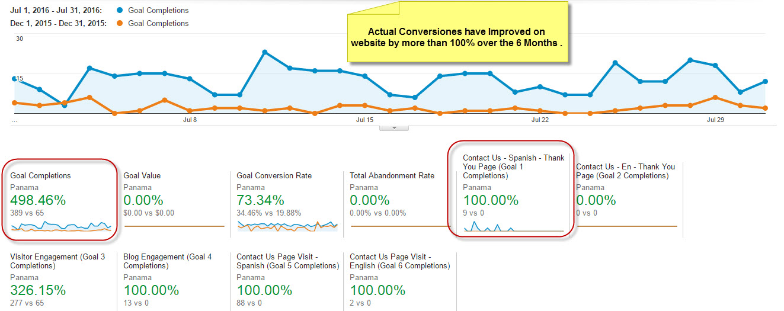

**Organic Traffic Graph**

The graph represents a incessant rise in the organic traffic through search engine

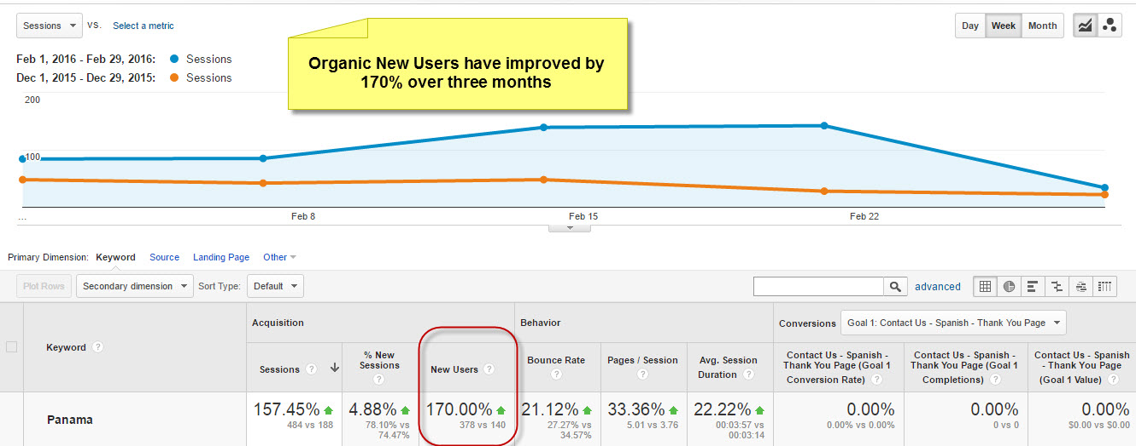

**Keyword Ranking Status**

|  |  |  |  |  |  |
| --- | --- | --- | --- | --- | --- |
| Sr No | Keywords | July 2016 | June 2016 | Jan  2016 | Dec  2015 |
| 1 | **bienes raices Panama** | 3 | 5 | 34 | NA |
| 2 | **inmobiliarias panama** | 5 | 10 | 24 | NA |
| 3 | **proyectos residenciales en panama** | 8 | 19 | 50 | NA |
| 4 | **compra y alquila panama** | 15 | 20 | 75 | NA |
| 5 | **apartamentos en venta en panama** | 12 | 19 | 65 | NA |

**Are you willing to give your website a drastic boost? Feel free to get in touch with our expert consultants**[ravish@vidushiinfotech.com](mailto:ravish@vidushiinfotech.com) or [ask@vidushiinfotech.com](mailto:ask@vidushiinfotech.com)